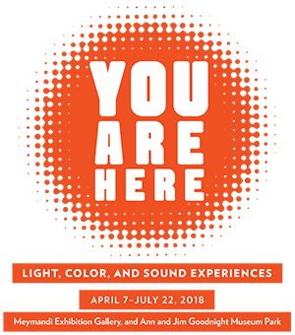

#0 Introduction

Audio Description Script by Fred Brack
You Are Here: Light, Color, and Sound Experiences features immersive art installations by 15 contemporary artists, including large-scale light works, sound installations, video works, mixed-media room-size environments, and site-specific projects. Some are delightfully low-tech, transforming ordinary materials into awe-inspiring visuals, while others make use of experimental new media, fusing art and technology in interactive works that change in response to the viewer.
The artists in this exhibition employ a diversity of media to create intriguing experiences that engage the senses, activate the imagination, and provide connections between the viewer and the work of art. They encourage visitors to roam— physically, visually, intellectually, emotionally, and metaphorically.
This exhibition takes over an entire floor of the North Carolina Museum of Art’s temporary exhibition galleries plus one exhibit in the Museum Park.
There are 21 exhibits in the collection, 15 of which will be audio described by Arts Access to enhance the experience for museum visitors with visual impairment. A few of the pieces can be touched, and some feature sound as an integral part of the exhibit. Listen to the audio description to get a feel for the visual aspects and set your expectations for your own enjoyment of the artistic experience.
(Audio description scripts by Debbie Hippler and Fred Brack, voiced by Fred Brack.)

